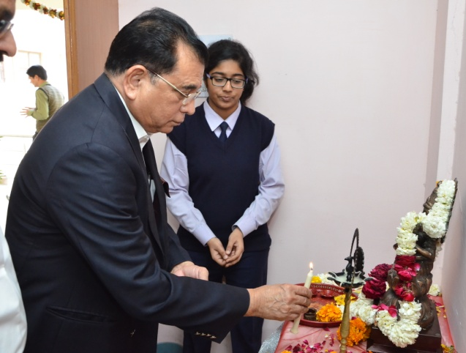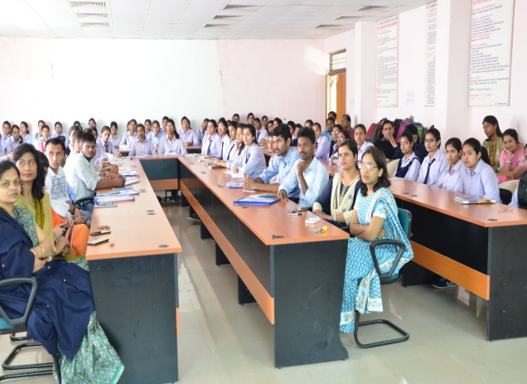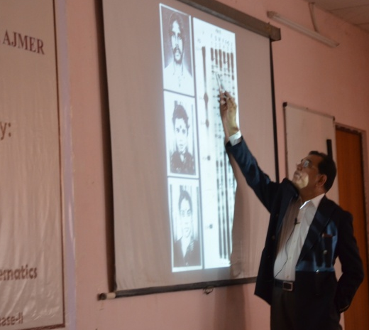

Visit of Padmashri of Prof. (Dr.) Lalji Singh

Padmashri & Former Vice-Chancellor, Banaras Hindu University, Prof. (Dr.) Lalji Singh visited GWEC, Ajmer on Feb. 27, 2017. He is popularly known as the "Father of Indian DNA fingerprinting". He addressed the faculty and students on the topic “Science of Establishing Identity: Past, Present and Future” in a National workshop organized by Department of Basic Sciences.

